Information Technology Solutions

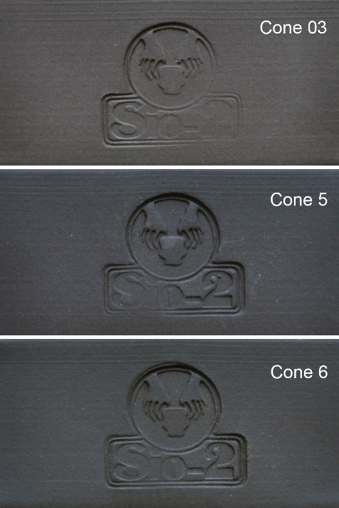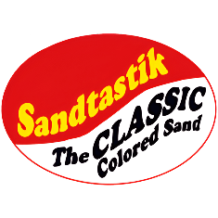

SIO-2® PRNI - Black Stoneware Clay with Impalpable Grog

**IS IRON OXIDE USED TO MAKE THE CLAY BLACK?**

**No. PRNI bodies use a very dark clay and a small quantity of manganese (<5%) to get the right color.**

**IS PRNI MICROWAVE SAFE WHEN FIRED AT CONE 6?**

**If PRNI clay is fired at cone 6, the objects are microwave and dishwasher safe (nevertheless, to ensure the longevity of the objects it's always better to avoid using them in the microwave and dishwasher).**

**IS PRNI SUITABLE FOR TABLEWARE (FOOD-SAFE)?**

**Yes. PRNI clay bodies are food-safe according to ISO 6486:1999 standards.**

**GLAZE RECOMMENDATIONS**

**Use zinc-free (Zn-free) glazes to prevent from unexpected reactions such as bubbling or color changes. Other elements that can react are zirconium (Zr) and tin (Sn). We recommend consulting your usual glaze supplier to ensure proper suitability with this ceramic clay body.**

**SIO-2® PRNI is a black stoneware clay body with 40% impalpable grog (up to 80 Mesh). Formulated for artistic ceramics, it is ideal for wheel-throwing and modeling smooth pieces with fine details.**

**The high content of grog confers an excellent behavior during drying and firing. Its beautiful and intense black firing color in oxidizing atmosphere is unique to the PRNI range of clay bodies. In a reduced oxygen atmosphere, metallic effects with shades of blue can be obtained.**

**SIO-2® PRNI clay is sensitive to cooling, which can cause breakage in pieces glazed on one side only, with glazes with a low expansion coefficient (<60x10-7°C-1). The critical temperature is between 200°C and 100°C (392°F and 212°F) during cooling. For this reason and as a preventive measure, we recommend not opening the kiln until it is cold (below 100°C – 212°F).**

**Firing range: Cone 5-6 (2205°F - 2269°F)**

**Biscuit: Cone 06 (1855°F)**

**40% Fine Grog (up to 80 Mesh)**

**Water content: 21%**

**Plasticity (IP Atterberg): 22**

**Carbonate content (CaCO3): 0%**

**Drying shrinkage: 7.0%**

**Firing shrinkage at Cone 6: 7.1%**

**Porosity (water absorption) at Cone 6: 1.3%**

**Dry bending strength: 4.6 N/mm2**

**Fired bending strength at Cone 6: 33.3 N/mm2**

**Thermal coefficient (a25-500ºC): 51.1x10-7°C-1**

info@sandtastik.com

P: 905-734-7340

F: 905-734-7733

www.sandtastik.com